G = Guide Buoy and may be passed on either side.
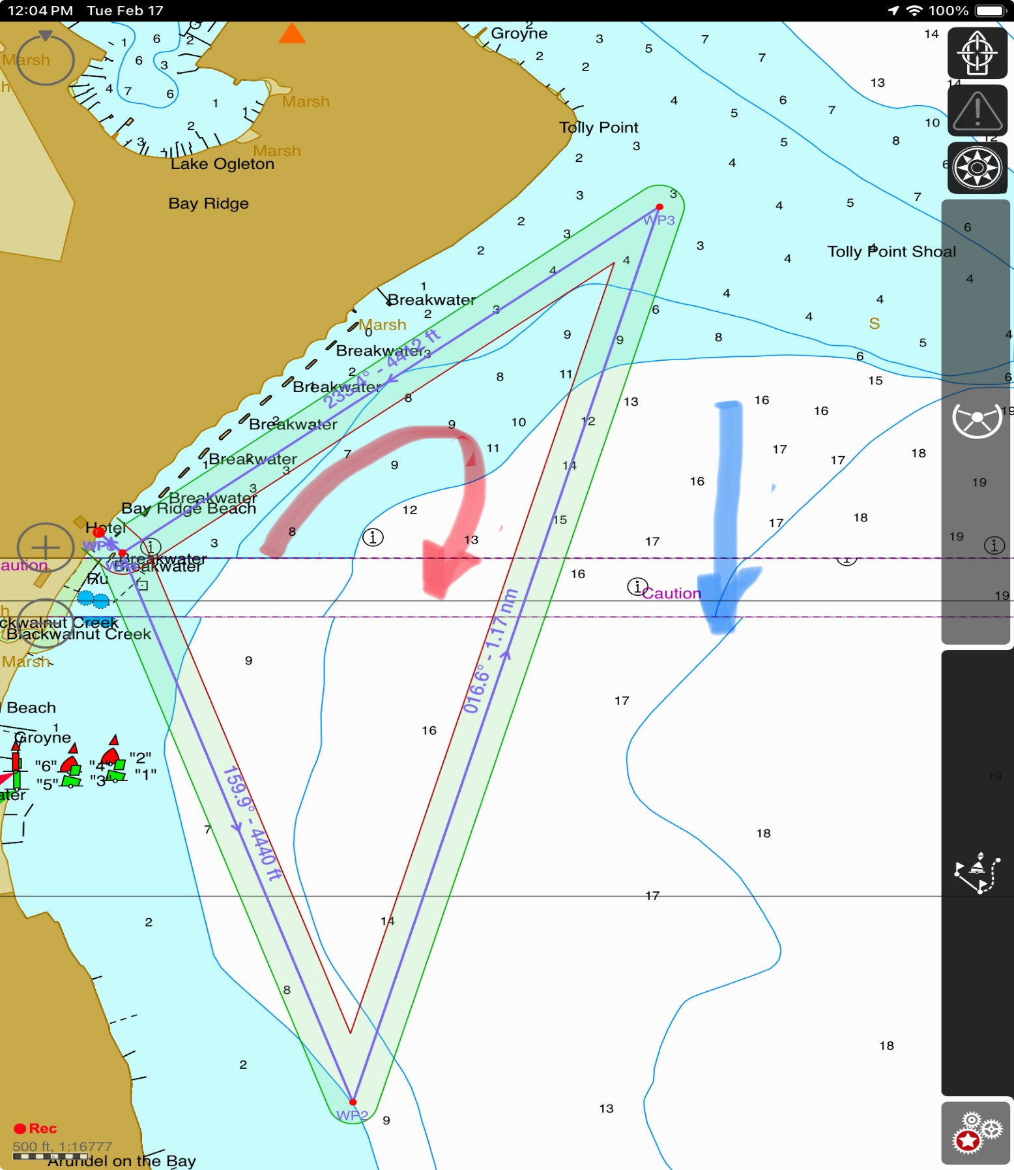
G10
G9
G8
Turn2
G7
G6
G5
G4
Turn 1
G3
G2
G1
Start/Finish

