Annapolis Frogman Swim
April 26, 2026
Expected Weather and Water Conditions for
All Swimmers, Kayakers, Safety Boats, and Jet Ski Operators
Ellis W. Merschoff

- Expected Weather on Event Day:
  - Cloud Cover: Partially Cloudy
  - Wind: 12 mph ENE Gusts up to 16 mph
  - Air Temperature: 51 F at start, warming to 61 F in afternoon
  - Precipitation: 20% Chance of light rain at start

- Expected Water Conditions on Event Day
  - Water Temperature: 65 F (Bay Temp 62F on 4/19/2026)
  - Wave Height: 1 foot
  - Tide: Low at 7:50 am/High at 2:04 pm
  - Current: Max Ebb 7:35 am at 0.58 kts (0.66 mph)
Slack: 10:54 am
  - Expected Current for Primary Course
    - Start to first turn- Current will oppose the swimmers by as much as 0.5 mph.
    - First to Second Turn Buoy: Current will aid the swimmers by about 0.3 mph.
    - Second Turn Buoy to Finish- Current will initially oppose the swimmers at about 0.2 mph decreasing to no current at finish.
  - Expected Current for 2 lap Alternate Course:
    - First Lap:
      - Start to first turn- Current will oppose swimmer
      - First turn to second turn- Current will aid the swimmers
      - Second turn to third turn – Current will oppose the swimmers
    - Second Lap:
      - Same as first lap, although the current effect will be less on each leg as overall current speed decreases to zero by 10:54 am.
- Additional Information
  - Marine Hazards: No known hazards at this time, however swimmers and kayakers should always be alert to the possibility of floating debris.
Swim: Clockwise (Red Arrow) Current: Left to Right from Beach (Blue Arrow)
G = Guide Buoy and may be passed on either side.
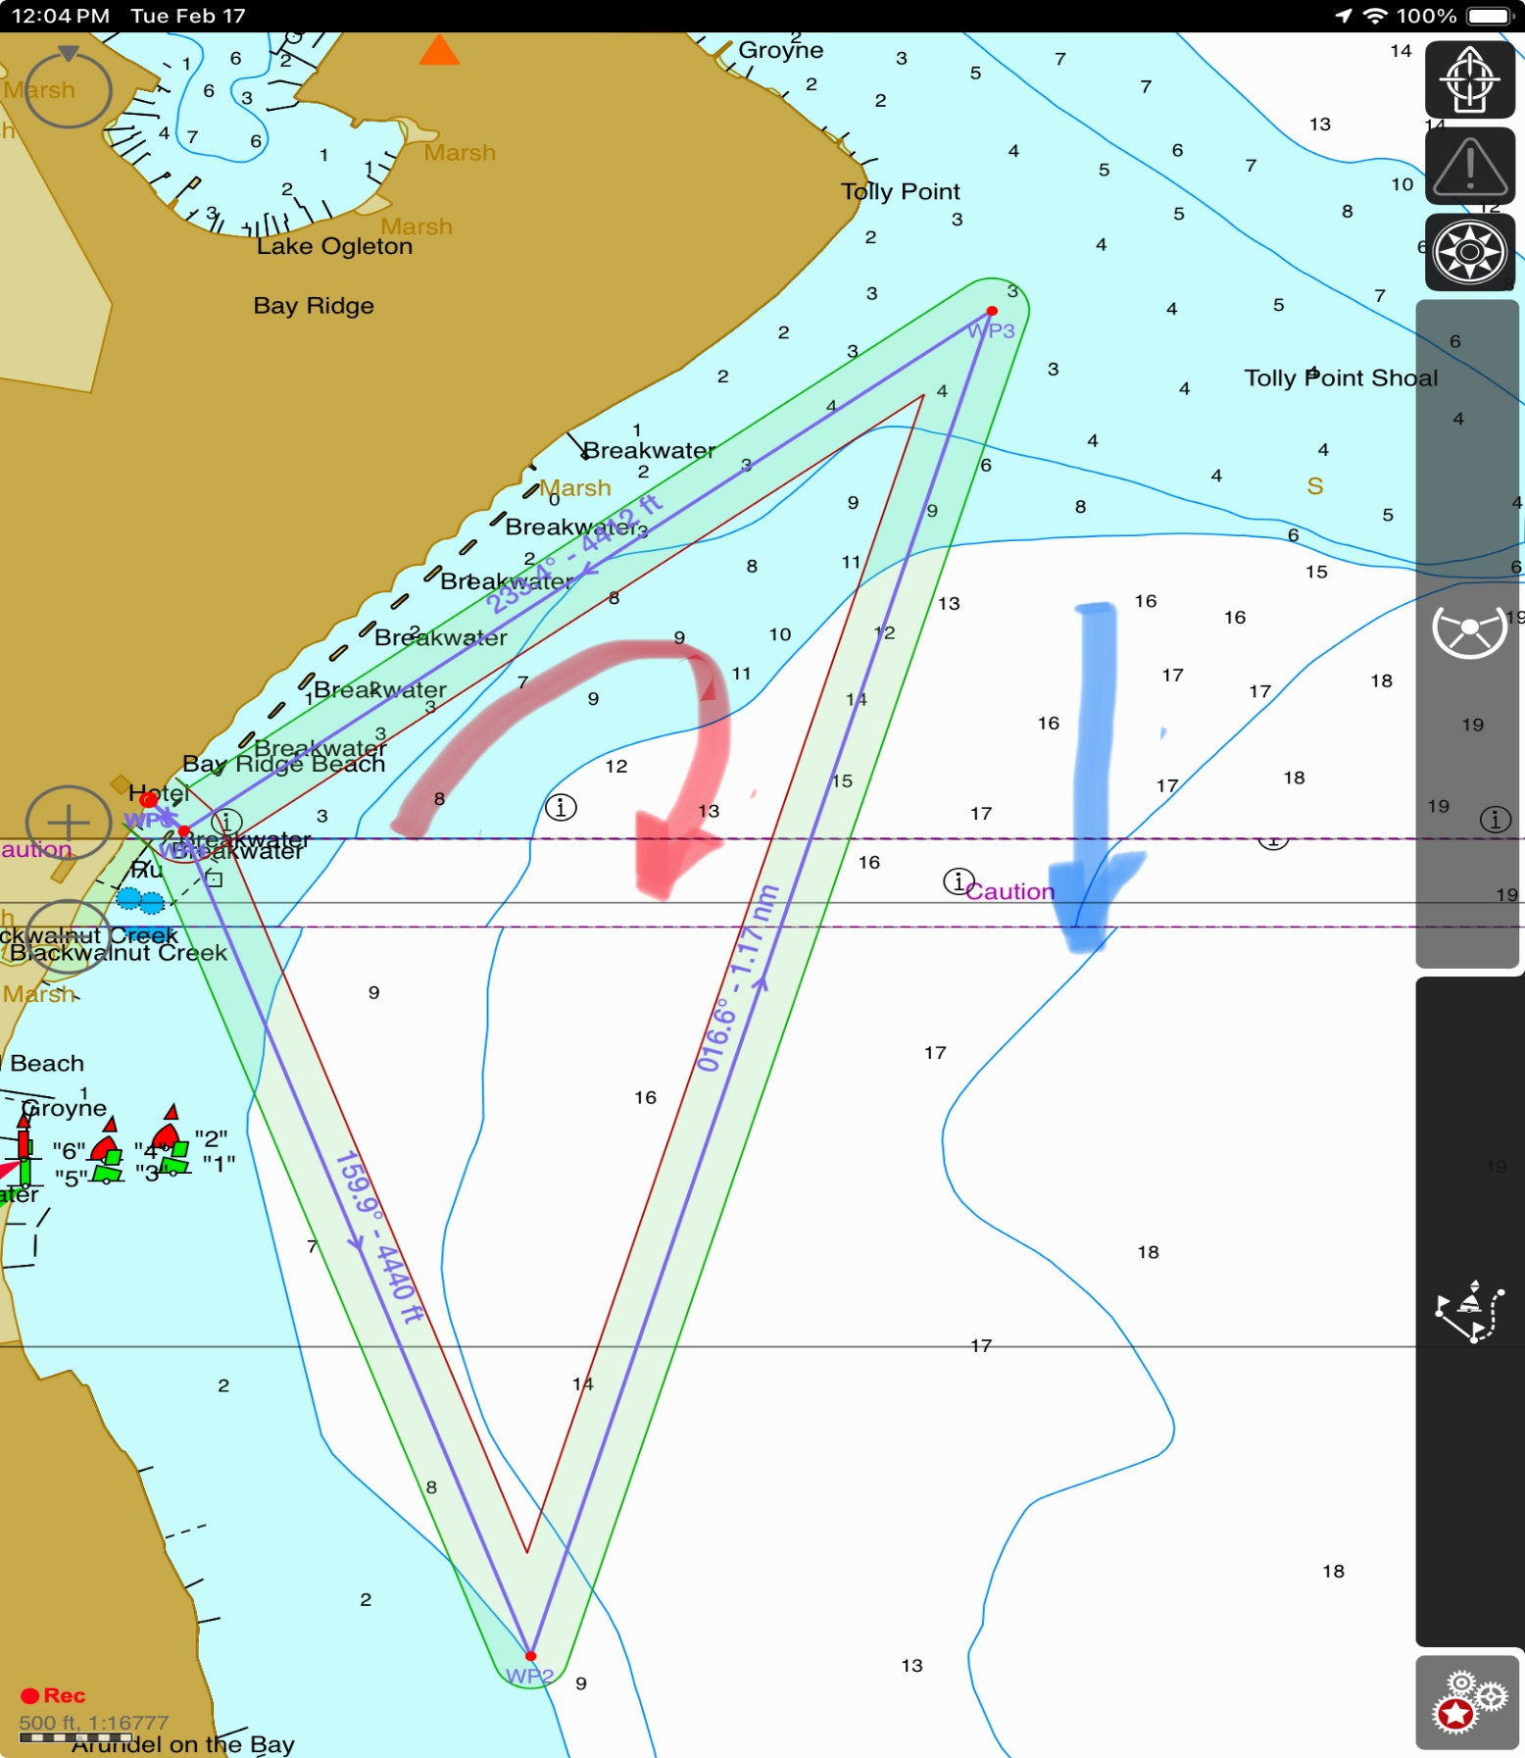
G10
G9
G8
Turn2
G7
G6
G5
G4
Turn 1
G3
G2
G1
Start/Finish

